AGRO BUDDY

—A Survey

**Ashish Patel**

**Abstract** This application provides a new technique for both farmers and Buyers to communicate over a single social medium. A Farmer can list and price his/her produce on our app to begin a new venture .The app provides very basic user interface for the farmers to work with. It also has many features with which a farmer can keep track of his daily affairs. The buyer or the consumer on the other hand will get a dedicated user interface for his/her affairs. A commercial consumer can list the crops which he/she wants to buy and start a dialogue with the farmers. Two types of consumers can register themselves, commercial and non-commercial. AGRO BUDDY aims at providing Freedom for farmers to sell their produce at the price they want to and also have a direct interaction with the consumers

**Keywords** Agriculture · Android · Crops · Horticulture

# Introduction

Android is one of the most popular operating systems for mobiles. AGRO BUDDY app is a flexible, easy to use and securely designed to benefit the farmers and consumers. It is used to digitize the market of retail selling and wholesale all in one single android mobile phone and manage them efficiently. Because of middlemen like APMC and other wholesale yards, farmers never get to obtain the actual price their produce or get any profits out of it. Consumers on the other hand have to pay more price due to the middlemen. With AGRO BUDDY the whole ecosystem of third party vendors will be restricted from entering one way business between consumers and farmers. The objective of this project is a mobile application developed for managing the list of food grains or agricultural produces that a farmer wants to sell and also for the buyers to see what is available in the market and the price which they would have to pay. Applications of AGRO BUDDY for its target demographic is given below

Farmer:

• Adds the products to be sold and prices them.

• Can access the list of requests given by non-commercial consumers

Commercial Consumer(HOPCOMS):

• Can read the list of produce given by farmers

• Buy the products

Non Commercial Consumer:

• Can request the products farmers usually produce as they buy in small-scale

• Requests need to be accepted by farmer to complete trade

# Literature Survey

Table 1, gives us a picturesque idea about the methodologies used by various authors in the field of agriculture using Android. It also gives the list of recommendations which we thought, could have been implemented in the system in the future.



Table 1: Comparison of similar innovations in the field of agriculture

# Methodology

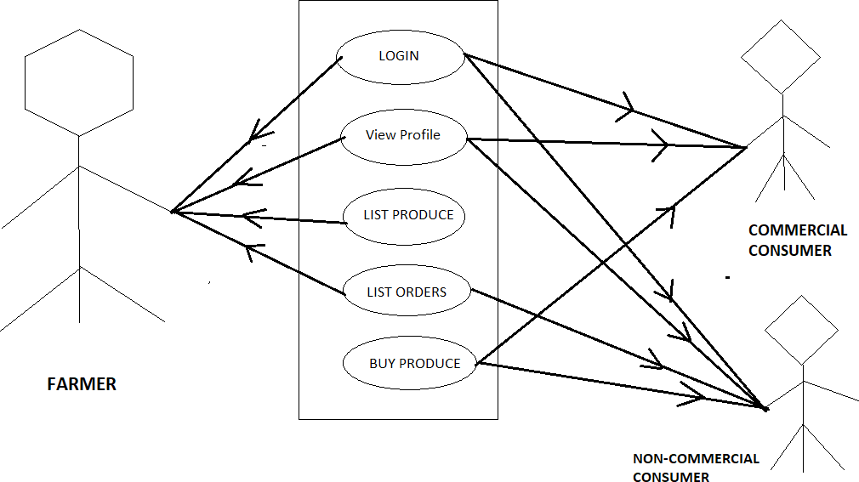

Figure : Use case diagram

We are here using XML and java for the front end and firebase for the backend as a server.

Firebase

Firebase is considered as web application platform. It helps query for inserting, updating,

deleting or adding data to it. It is the backend of a system that is used as a database for

storing data.

Firebase real-time database feature is very easy to use. Once the Firebase and database

dependency is added to the app, unstructured data can be added to database.

Storage

Image files can be stored in the app. The data stored is highly secured and is robust in

nature, means it resumes from the last point if any network error occurs. The steps below

are to be followed to use storage feature in Android application: added to the application.

Firebase and Android App

An Android application has been developed for the demonstration of Firebase. In this app

images along with strings are loaded to Firebase and retrieved from Firebase similar to

Instagram. For the development of an Android app to demonstrate the use of Firebase,

prototyping model has been followed. Steps for connecting App to Firebase:

**Step 1**: An account in the Firebase Login has to be created at

https://www.firebase.com/login/ using the Google account.

**Step 2** : Creating a new application on Firebase. Firebase creates a new application when

one logs in for the first time. Also, at the bottom left corner, one can find an option to

create a new application on the Firebase server. The app URL has to be unique among all

applications deployed on Firebase.

**Step 3** : Next step is to add Firebase as a project dependency. Make changes to the

following lines to the build.gradle file, which is located in the app’s project folder, and

not the root folder. After adding any dependency, one has to make sure to sync the

application. If there is any build error complaint about duplicate files then one can choose

to exclude those files by adding the packaging Options directive to the build.gradle file:

android.

**Step 4** : Next, add permissions to Android application, add network permission to the app,

the same way it has been done for parse earlier. Now add the following line to the

AndroidManifest.xml file: Firebase is a Backend-as-a-Service — BaaS — that started as an

YC11 start up and grew up into a next-generation app-development platform on Google

Cloud Platform.

JAVA

There are several ways to create apps for Android devices, but the recommended method

for most developers is to write native apps using Java and the Android SDK. Java for

Android apps is both similar and quite different from other types of Java applications.

If you have experience with Java (or a similar language) then you’ll probably feel

comfortable diving right into the code and learning how to use the Android SDK to make

your app run. But if you’re new to programming or object-oriented languages then you’ll

probably want to get familiar with the syntax of the Java language and how to accomplish

basic programming tasks before learning how to use the Android SDK.

Android Studio

Android is one of the most popular mobile device platforms. The Android platform allows

developers to write managed code using Java (http://www.developer.com/java) to manage

and control the Android device. Android Studio is a popular IDE developed by Google for

developing applications that are targeted at the Android platform. Note that Android Studio

has replaced Eclipse as the IDE of choice for developing Android applications.

Some of the interesting features of Android Studio include the following:

• Support for a fast emulator

• Support for Gradle

• Support for plenty of code templates and GitHub integration

• Support for Google Cloud Platform

• Support for template-based wizards for creating Android designs and components

• Support for rich layout editor

• Support for deep code analysis

• Support for extensive set of tools and frameworks

1. **Conclusion**

India is one of the fastest growing economies in the world. In the 21st century we are seeing a technological revolution overtake our country and everyone is not only basking in the new benefits of technology, they are also looking for new ways to improve the existing technology. India has been a primarily agricultural society since ancient times. Even now, though agriculture contributes a third highest share to the Gross Domestic Product of our nation, almost 60% of the population is engaged in some form of agricultural activity. This reflects a massive shortcoming in our agricultural process. Ideally India should be the biggest exporter of grains of pulses because of her farmer population.

When one tries to look at the problems plaguing the Indian agricultural process, from top to bottom, we saw a lot of the causes : corruption, out-dated agricultural practices, insufficient incentives from the government, landlords, middlemen etc. We decided to tackle the issue of middlemen because it is extremely rampant and downright devious as it takes money out of the pockets of both farmers and consumers. After speaking with many farmers our team decided to tackle the issue of HOPCOMS.

The Horticulture Producers’ Co-operative Marketing and Processing Society Ltd. Popularly called as HOPCOMS was established with the principal objective of establishing a proper system for the marketing of fruits and vegetables, to benefit both the Producers the consumers. Prior to the establishment of HOPCOMS, no proper system marketing of horticulture produce was in existence. Now due to lack of innovation, farmers are in the clutches of the middlemen and the whole system is benefitting the middlemen and not the farmers and the consumers. AGRO BUDDY aims to change that by creating a holistic market place for both HOPCOMS and farmers with a consumer portal included for more ease of access and better efficiency.

1. **References**
2. Soumalya Ghosh, A. B. Garg , Sayan Sarcar , P.S.V.S Sridhar , Ojasvi Maleyvar , and Raveesh kapoor : Proceeding of the 2014 IEEE Students' Technology Symposium
3. S. Revathi , S. Sathya Prasad : 2020 4th International Conference on Computer, Communication and Signal Processing (ICCCSP)
4. Divya Sawant , Anchal Jaiswal , Jyoti Singh , Payal Shah : 2019 IEEE Bombay Section Signature Conference (IBSSC)
5. Manav Singhal , Kshitij Verma , Anupam Shukla : Proceeding of the 2016 IEEE Students' Technology Symposium
6. S. Mokshapathy : International Journal of Horticulture, 2013, Vol. 3, No. 20
7. H. M. Chandrashekar : International NGO Journal Vol. 6 (5), pp. 122-132, May 2011
8. Kalyani Khodaskar : 2015 Fifth International Conference on Communication Systems and Network Technologies
9. Pranav Shriram , Sunil Mhamane : 2018 3rd International Conference on Inventive Computation Technologies (ICICT)
10. “Overview Guides Reference Samples Libraries Support Go to console” Documentation Firebase, https://firebase.google.com /docs/
11. Stack Overflow, <https://stackoverflow.com>
12. YouTube, https://www.youtube.com/